**Chapter 1**

**INTRODUCTION**

**1.1 Overview**

Traditionally, labour relations were considered as a relationship between employees and employers. But nowadays, this has become a burning issue consisting of the relationship between workers, employers and the social environment of the organization. It is a dynamic socio-economic process that makes a social dialogue among employees, employers and the organizational social environment. The importance of the human factor in any organization cannot be overemphasized. Land and capital as non-human factors of production are worthless unless there is the labour to utilize the machinery and the tools, and unless there is the management to coordinate all other factors towards the achievement of the goals of the organization, be it production of goods or delivery of services. Indeed, an organization can only be as effective and efficient as its human resources.

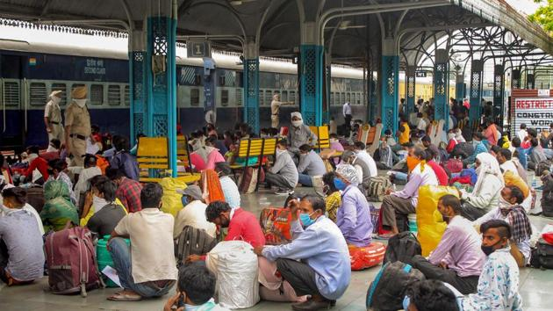Traditional personnel management sees human beings in an organization as machines but if these machines are not constantly lubricated, then they may breakdown or cease to function and that is just about what the human resource management sets out to accomplish in organizations. The strength of any organization lies in its manpower, no matter the size of an organization or the worth of its owner, the organization and its life span are in the hands of the people working in that organization.

The importance of human resources in an organization is further buttressed by the observation of Romana and Anca (2013), they observed that in most organizations people are now recognized as the vital asset whose knowledge, skills and abilities must be deployed to the maximum effect if the organization is to become successful. They further observed that the value of an organization relating to the people it employs and its human resource strategies is gaining recognition and is generally accepted and goes to say that this has implications for long-term sustained performance. Managers and employers of labour, therefore, take very seriously, the training and development of its workforce (labour) to make them more effective and efficient, so that the objectives of organizations are achieved with minimal efforts. In general, there is a need for good human resource management.

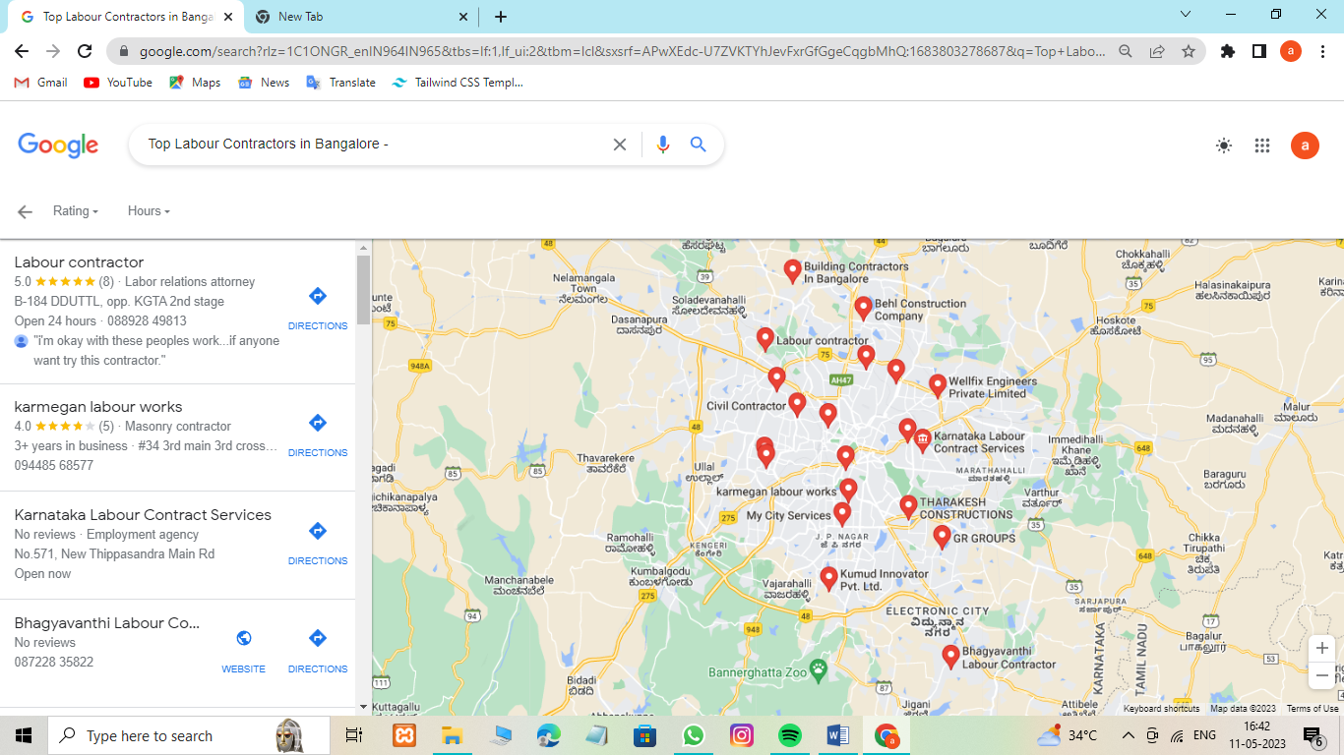

The recruitment and selection process has to be standard and based on merit. Orientation, deployment, training and development have to be put in place. Adequate compensation, benefits, rewards and motivation have to be provided for employees and welfare issues addressed at the right time. Workers wellbeing should be given adequate consideration According to Hassan (2016). The relationship between labour and management determines the kind of industrial climate that may prevail in an organization. In the same vein, Long(2014) observed that there is a need to maintain proper relations with employees and trade unions. That is, there must be a cordial relationship between the two major human elements of production, labour on one hand, and the managers on the other hand. This is where the concept of labour management relation becomes significant.

Labour management relation is concerned with the relationship between workers, not as individuals but in their collective identity. Labour-management relations deal with the internal arrangement between employers and workers’ unions (the trade unions) in bilateral relationship within an industry, across industries or within an enterprise, to regulate their relations affecting employment and its compensation (Yoder, 1958). Indeed, no meaningful development could be achieved in an environment devoid of peace and understanding, most especially, one involving labour and management. Labour-management relations refers to interactions between employees, as represented by labour unions, and their employers. Labour unions are organizations of employees in particular industries, companies, or groups of industries or companies, who join together to further workers' interests. The primary focus of Labour-Management Relations should be on the grievance, handling the industrial dispute, and interpretation of labour laws, etc. it provides a context in which organizational rules and regulations are framed so that organizational roles assigned to members are performed.



The study of labour-management relations refers to the rules and policies which govern and organize employment, how these are established and implemented, and how they affect the needs and interests of employees and employers (Von Otter, 2007). Hence, labour relations or employee relation of industrial relation is a system that makes the social dialogue between employees, employers and society/government. It refers to all means of the relationship between management and employees, unions and management, unions and employees and between the employees themselves. It is a joint effort of these major influences that produce harmonious industrial relations between them. Its concern is to promote a healthy and harmonious relationship between employees and employers. It is said that the most complicated set of relations that managers deal with is the issue of labour management relations. Efficient maintenance of labour relations helps the human resource managers in developing a harmonious environment within the organization which, in turn, helps the organization in effectively achieving its goals and objectives. Well managed labour relations provide a competitive advantage to the organization by negating the hassles arising out of labour or union-related issues and conflicts. Labour-management relations is concerned with the internal arrangement between employers and trade union in a joint relationship within an industry or across industries or within an enterprise to regulate their relations affecting employment and its compensation, this relation connotes a relationship between workers and the employers. However, human wants are many while the means of satisfying them are very limited. This economic principle is valid for the organization just as it is valid for individuals. The management may have the interests of is workers at heart, they may tend towards the practice of the soft model of human resource management, but would definitely, not be able to satisfy all the demands of its workers due to scarcity of resources. Hence, conflicts can hardly be completely avoided in labour-management relations. Conflicts form an integral part of the industrial relation system, it is inevitable. Some conflicts are legitimate and even desirable, such are not disruptive, but then, a delicate balance is required to obtain the advantages and restrict the disadvantages of organizational conflicts (Sacks, 1979). But due to the adverse effect of conflicts in organizations, conflicts must be resolved and properly managed. The ability of management to resolve and manage conflict with minimum friction, whenever it occurs, among the workers or between the workforce and management is important to the growth and development of any organization.

**Objectives of the project work**

The general objective of this paper is to introduce the subject of labour-management relations. While the specific objectives are to:

* Discuss the different types of conflicts,
* Examine their manifestations and
* Identify various methods of conflict resolution

II. Literature Review

Conflict is as old as man, it is a natural phenomenon in all human society that occurs in man's day-to-day activities. Given that every individual is unique, some views and opinions will defer from those of others. The reason is that people of various background, culture, religion and belief come together and live in the same space. Conflict can come in form of serious disagreement, misunderstanding or argumentabout something important. It could also be a state of mind in which one finds it impossible to make a decision. The conflict could also mean fight, battle, contention, clash, incompatibility, oppositional disturbance, sharp disagreement and struggle. Conflict is a kind of disagreement through which the parties involved perceive a threat to their existence, need, interest or concern. According to Oyeshola (2005),conflict is part of human experience, and to keep our sanity, we must know how to handle it creatively. Healthy conflict can lead to growth, innovation, and new ways of thinking which can lead to development. If it is well managed, it leads to mutual benefits and it could strengthen the relationship. Therefore, conflict in itself is not a problem, it is when conflict is poorly managed or when it becomes intractable or unresolved that it becomes a problem.

**a) Types of Conflict**

Whether a conflict is good or bad depends on the type of conflict, but to say that conflict is all good or bad is inappropriate and naïve. Conflict in an organization is a situation in which the expectation(s) of a person or group is hindered or about to be hindered by another person or group. Conflicts are part and parcel of human beings, they are daily occurrences within an individual and among people. Conflict occurs in both public and private organizations.

**b) Functional or Constructive Conflict**

This type of conflict supports the goals of the group and improves its group's performance. The interactionist view does not propose that all conflicts are good but the argument is that if conflicts lead to normal competition among groups and the groups work harder and produce more, it is advantageous to the group and the organization. It is viewed as a confrontation between two ideas, goals and parties that improve employees and organizational performance. The major benefit of constructive conflict is that it gives its members a chance to identify the problems and see the opportunities, they are fully involved, which may lead to new ideas, learning and growth among individuals and by extension the growth of the organization.

**c) Dysfunctional/Destructive Conflict**

As earlier mentioned, conflict is inevitable and desirable in organizations, but if not properly addressed by way of effective handling, may lead to temporal or permanent damage. They hinder group performance and can tear relationships apart, thus, interfere with the exchange of ideas, information and resources in groups and between departments. This type of conflict hinders and prevents organizational goals from being achieved. Destructive conflict as implied by the name usually hinders organizational performance and leads to decreased productivity. It is characterized by competing for individual interests overriding the overall interest of the business. It could manifest in several ways such as opposing groups forming within a company, inability to move forward and productivity slowdowns, loss of trust, avoidance of working with some or all people, hiding behaviour from outsider's view, call by some for outsider help, feeling of being unwelcome, anger, confusion, anxiety and absence of proper communication.

**d) Causes of Conflict**

Conflict is part of organizational life and may occur within and between individuals, between the individuals and the group, within and between groups and sometimes within the individual. Ordinarily, the conflict will bring to the fore management defects which will lead to reexamination and adjustment that will, in turn, lead to the overall effectiveness of the organization. Therefore, conflict can occur as a result of structural or personal factors.

**Structural Factors**

i. Specialisation: Over some time, employees tend to become specialists in a particular job or get a general knowledge of many tasks. Sometimes the erroneously assume the role of a specialist when in reality they are not. This can lead to conflict because they have little knowledge of each other’s job responsibilities. For example, a sales representative at a tailors shop can say that a suit can be made in a time that is not realistic, since the sales representative does not know much about the tailor’s job, he should not give an unrealistic deadline when the suit will be ready. This situation can lead to conflict between the sales representative and the tailor.

ii. Common Resources: Some resources in an organization may be scarce. In many work situations, resources have to be shared. Resource scarcity leads to conflict because each person that needs the same resources necessarily undermines others who pursue their own goals. Limited resources may include money, supplies, people or even information. For example, according to Mcshare and Glinow, (2008). The Redmond Washington based software company may dominate several markets, but its staff members still disagree over limited resources. Sartorial support computer time can contribute to conflict. Considering the company that installs a new computer for administrative and research purpose, at first, there is plenty of computer time and space for both uses. However, as both factions make more and more use of the computer, access becomes a problem and conflict may erupt.

iii. Goal Differences: The possibility of conflict increase substantially when departments in the organization have different or incompatible goals. For example, the goal of a computer salesperson is to sell many computers as fast as possible. The manufacturing facility may, however, lack the capacity to meet the salesperson's promises. In this instance, conflict may occur as two persons have different goals or incompatible goals.

iv. Inter-dependence: Often, conflict tends to increase with the level of task interdependence. When a person has to depend on someone else to complete a task, it becomes easier to blame a coworker when something goes wrong.

Interdependence, as a rule, exists when team members must have an interest in the process of work and receive outcomes that depend on the performance of others.

v. Authority Relationships: Conflict is any situation in which two or more parties feel themselves in opposition to power, status or property. In many organizations, there is an underlying tension between managers and employees because most people do not like being told what they have to do. In many organizations, managers/supervisors have privileges sometimes people try to engage in conflict to increase their power or status in an organization. Many strict managers often have conflicts with their employees.

vi. Roles and Expectations: A role is the expected behavior of an individual in society or this case in an organization. Every employee has one or more roles in the organization. These roles include such elements of job title, description of duties and agreement between the employee and the organization. Manager-subordinate conflict can result when the subordinate's role is not determined and each part has a different understanding or misunderstanding of that role.

vii. Jurisdictional Ambiguities: Employees tend to pass unwanted responsibilities to others when responsibilities are not clearly stated. When the lines of responsibility in an organization are uncertain,

**Chapter 2**

**LITERATURE SURVEY**

This chapter explains the existing aspects of the proposed project work.

**2.1 Various document repositories**

**IndiaMART**

IndiaMART was launched in 1996 as a directory of the websites for customers in the Delhi-NCR region by two cousins Dinesh Agarwal and Brijesh Agrawal. At that time India had only 15,000 internet users. By 1999, the directory had more than 1000 listings.

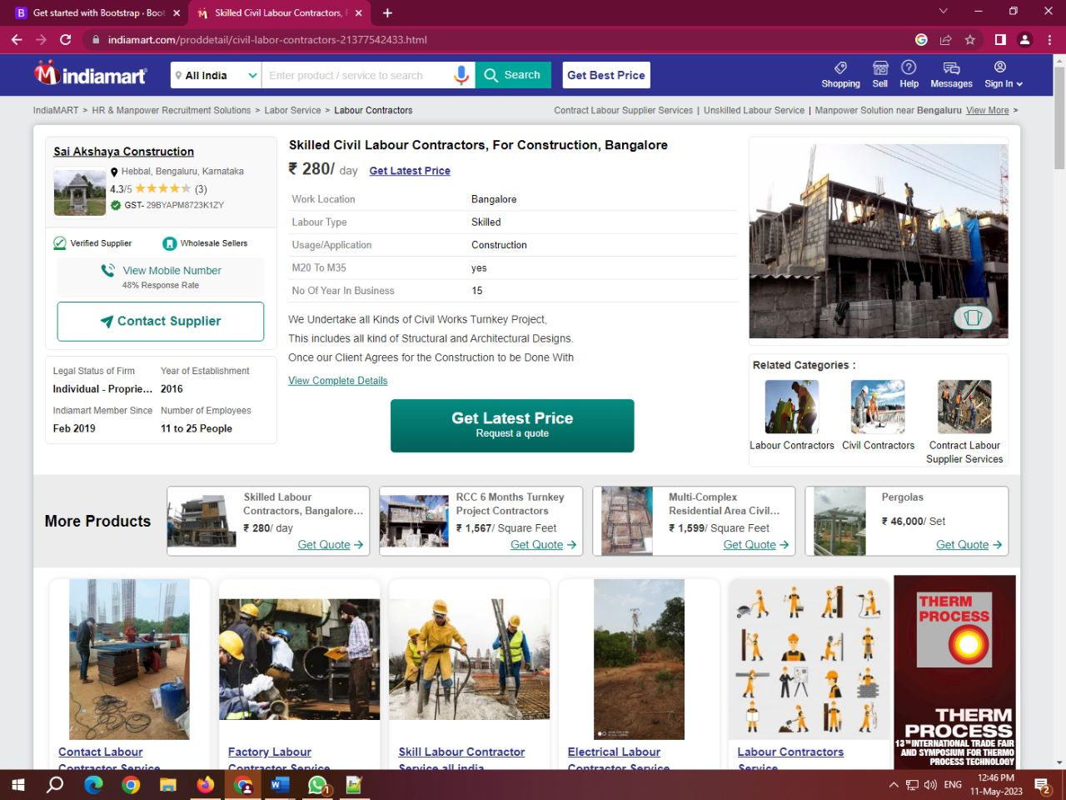 After overcoming the dot-com bust, in 2008–09 when the recession hit the US, the company decided to pivot the focus from export oriented business to India-focused B2B market and raised $10 million in Series A round funding from Intel Capital, a part of which was invested in IndiaMART, One97 Communications and Global Talent Track.

* In November 2014, IndiaMART started promotional campaigns featuring Indian film actor Irrfan Khan as its brand ambassador.
* In March 2016, it raised Series C Funding from Amadeus Capital Partners and Quona Capital to scale up the activities of IndiaMART and Tolexo.

In 2016 and 2019, IndiaMART invested in ProcMart and Vyapar.

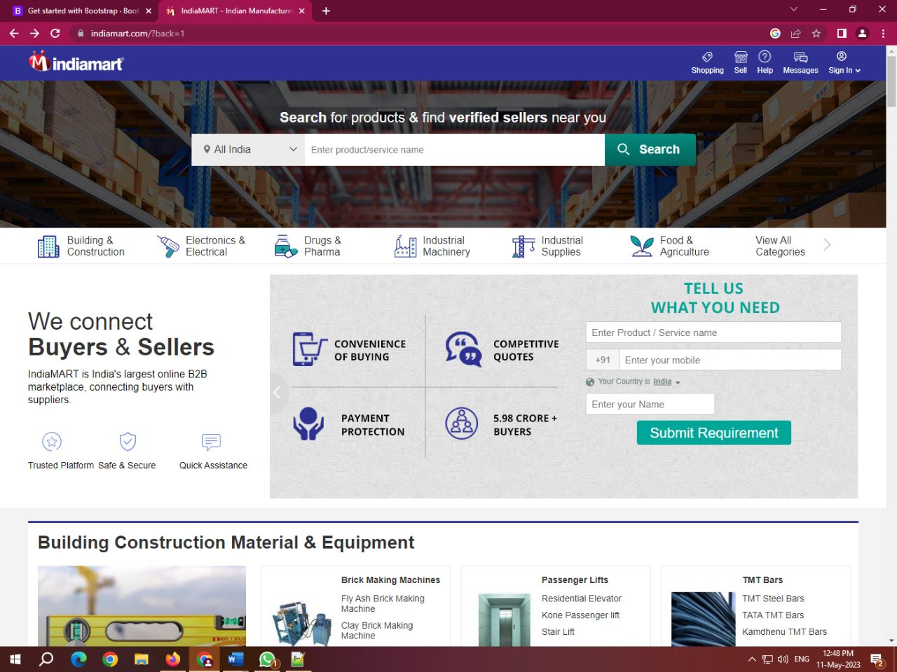

* In June 2018, IndiaMART filled draft papers with SEBI to raise ₹600 crore through IPO and list on NSE and BSE. In June 2019, IndiaMART went public via an IPO of ₹47by the end of the final day of the bidding. IndiaM4 crore. The issue was oversubscribed by 36 times ART became the first online B2B marketplace to go public in India, and the first company launch its IPO in the second tenure of Modi government.

As of 2019, IndiaMART was the largest Indian e-commerce platform for businesses with about 60% market share, according to KPMG.

**URALUNGAL LABOUR CONTRACT CO-OPERATIVE SOCIETY**

 Uralungal Labor Contract Co-operative Society (ULCCS) is India’s oldest worker cooperative. Located in Calicut Kerala, it was established in 1925 by Palery Chandanman with blessings from Vagbhadananda. The Uralungal Labor Contract Co-operative Society has close to 1415 members and has completed more than four thousand work projects. It undertakes the construction work for various government departments, such as Public Works Department, National Highway, Irrigation, and Tourism. ULCCS Charitable Foundation runs a training institute in Kozhikode for the neurodiverse.

The Uralungal Cooperative has undertaken over 1000 core projects, including the Kozhikode Sarovaram Project, city road improvement, the renovation of the Kappad Beach, the Kozhikode Arayidathupalam Bridge, the Iringa Craft Village, the Edasseri Kadavu Bridge and the Government Engineering College, Alappuzha, the six-laning project of NH66 from Talapady to Chengala reach of Kasaragod District.

The origin dates back to the times when barbarism and superstition reigned. In Uralungal, Kozhikode district, where people used to live without jobs and wages, few villagers reached the temple complex at Puthalath in Mahe to hear the discourse of Vagbhatananda Guru. Impressed by the Guru's talk, who shared the Renaissance ideas, they invited Vagbhadananda to their homeland.In 1917, Palery formed a spiritual school

under the leadership of a guru who arrived in the Karakkad region of Uralungal. No one in the country was given a job. The young men approached the Guru with sarcasm. The Guru said that this should not hinder the progress of the proceedings and suggested a simple solution: to start a cooperative group by organizing young people who are willing to work. Thus, on 13 February 1925, the Unemployed Mutual Assistance Group of Mercantile Workers registered a co-operative group called Uralungal Kooli Velakarude Paraspara Sahaya Sahakarana Pagham. This is the story behind the birth of the Uralungal Labor Contract Co-operative Society (ULCCS Ltd), which has transformed the face of Kerala by building major over-bridges, highways, and fly-overs.[citation needed] a hiring process. Ural



The name of the village of Uralungal, a village in North Malabar, that no one knows about, was signed by Vagbhatanandan, one of the lamps of the Kerala Renaissance. The work undertaken by the Uralungal Society, in the beginning, was the construction of a fence, a small wall, and a well. The Guru had already strictly stated that the aim was not to make a profit. The ULCCS says that these workers are the beneficiaries of today's upliftment, ensuring quality, free of corruption and discipline. Says Chairman Paleri Rameshan. It was a time when the railway's Overbridge at Chorodu along the national highway, until then the ULCCSS had been confined to the Vadakara taluk and adjoining areas, taking only minor road contracts. The contract for the road to the Chorodu overbridge on the Vadakara-Thalassery highway was taken. At the time, the firm did not have the necessary equipment and equipment to perform the big contract work. The undertaking of a six-crore construction project in 1999 was a turning point in the growth of the worker cooperative. ULCCS did not even have its engineer but completed the work in due time and in good standing. All began to know the name of Uralungal. The movement did not have to seek contract work again. A large number of government and private sector construction workers came to Uralungal. To ensure quality and punctuality, the job has become ungal was also responsible for acquiring some private companies and completing ten-fifteen years' worth of work that was halfway completed.

**Contract Labour Management System: NALCO**

National Aluminium Company Limited being a leading CPSE and a responsible Corporate Citizen believes that “Human Resources” are the vital aspect of the organization, whether they are engaged directly or indirectly in the Company. As part of this philosophy, it takes utmost care of its people including the contract labourers. The engagement of contract labourers in NALCO is regulated by the Contract Labour (Regulation & Abolition) Act, 1970 and various other rules made by the Appropriate Government in this regard. In order to go ahead with the digitization drive by the Government of India to bring in transparency and to facilitate the maintenance of records in electronic form under the Information Technology Act, 2000, NALCO has developed a centralized portal for Contract Labour Management.

The portal will help in digitization of most of the transactions pertaining to contract labour engagement; thereby reducing human intervention and increasing transparency in the system. The portal will also incorporate the Combined Forms under the Ease of Compliance to Maintain Registers under various Labour Laws & Rules, applicable to the contract labourers. The system, developed in-house, maintains a comprehensive database of all contractors and contract labourers engaged at different Units/Offices of NALCO and will facilitate fulfilment of NALCO’s responsibility as a sensible Principal Employer under the statute. The system will have inherent mechanism to validate payment of minimum wages, other statutory dues like EPF and ESI, generate wage slips, employment cards and several statutory Forms/Registers/Returns related to contract labour deployment as required under the statutes. Compliance by contractors on payment of wages and other benefits to the contract labourers will be ensured through this portal.

**Labour Management Information System**

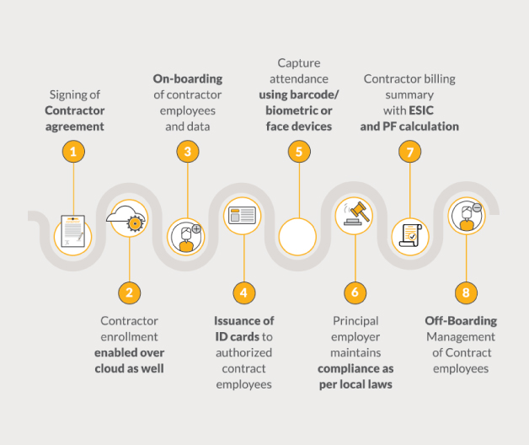

Main objective of Labour Management System is maintaining contractor and subcontractor details. Labour Management attendance is extremely tedious errand which connects with labour additionally require monstrous printed material.

The goal of Labour Management Information System Software is keeping up contractual worker and subcontractor subtle elements. emSphere has comprehended the requirements of such organization and has propelled its Labour Management System.

The framework helps in getting contract points of interest and permit subtle elements. This product is created by consolidating extensive examination, sees from the specialists of work expert fields and input of work consultancies. It will deal with your Organization all the more proficiently. A wide range of issues identified with Labour and Contractor Management with their Attendance issue is fathomed astoundingly by the product.

**2.2 About HTML**

HTML is the standard markup language for Web pages. With HTML we can create our own Website. The HyperText Markup Language, or HTML is the standard markup language for documents designed to be displayed in a web browser. It can be assisted by technologies such as Cascading Style Sheets (CSS) and scripting languages such as JavaScript.

Web browsers receive HTML documents from a web server or from local storage and render the documents into multimedia web pages. HTML describes the structure of a web page semantically and originally included cues for the appearance of the document.

HTML elements are the building blocks of HTML pages. With HTML constructs, images and other objects such as interactive forms may be embedded into the rendered page. HTML provides a means to create structured documents by denoting structural semantics for text such as headings, paragraphs, lists, links, quotes and other items. HTML elements are delineated by tags, written using angle brackets. Tags such as <img /> and <input /> directly introduce content into the page. Other tags such as <p> surround and provide information about document text and may include other tags as sub-elements. Browsers do not display the HTML tags, but use them to interpret the content of the page.

HTML can embed programs written in a scripting language such as JavaScript, which affects the behavior and content of web pages. Inclusion of CSS defines the look and layout of content. The World Wide Web Consortium (W3C), former maintainer of the HTML and current maintainer of the CSS standards, has encouraged the use of CSS over explicit presentational HTML since 1997.

**Example**

<!DOCTYPE html>

<html>

<head>

<title>Page Title</title>

</head>

<body>

<h1>My First Heading</h1>

<p>My first paragraph.</p>

</body>

</html>

**Example Explained**

The <!DOCTYPE html> declaration defines that this document is an HTML5 document

The <html> element is the root element of an HTML page

The <head> element contains meta information about the HTML page

The <title> element specifies a title for the HTML page (which is shown in the browser's title bar or in the page's tab)

The <body> element defines the document's body, and is a container for all the visible contents, such as headings, paragraphs, images, hyperlinks, tables, lists, etc.

The <h1> element defines a large heading

The <p> element defines a paragraph

**HTML Documents**

All HTML documents must start with a document type declaration: <!DOCTYPE html>. The HTML document itself begins with <html> and ends with </html>. The visible part of the HTML document is between <body> and </body>.

**The <!DOCTYPE> Declaration**

The <!DOCTYPE> declaration represents the document type, and helps browsers to display web pages correctly. It must only appear once, at the top of the page (before any HTML tags). The <!DOCTYPE> declaration is not case sensitive.

**HTML Headings**

HTML headings are defined with the <h1> to <h6> tags. <h1> defines the most important heading. <h6> defines the least important heading:

Example

<h1>This is heading 1</h1>

<h2>This is heading 2</h2>

<h3>This is heading 3</h3>

**HTML Links**

HTML links are defined with the <a> tag:

Example

<a href="https://www.w3schools.com">This is a link</a>

The link's destination is specified in the href attribute. Attributes are used to provide additional information about HTML elements.

**HTML Images**

HTML images are defined with the <img> tag. The source file (src), alternative text (alt), width, and height are provided as attributes:

**Example**

<img src="infonics.jpg" alt="infonics.co.in" width="104" height="142">

How to View HTML Source?

Have you ever seen a Web page and wondered "Hey! How did they do that?". Right-click in an HTML page and select "View Page Source" (in Chrome) or "View Source" (in Edge), or similar in other browsers. This will open a window containing the HTML source code of the page. Right-click on an element (or a blank area), and choose "Inspect" or "Inspect Element" to see what elements are made up of (you will see both the HTML and the CSS). You can also edit the HTML or CSS on-the-fly in the Elements or Styles panel that opens.

**2.3 About JavaScript**

JavaScript often abbreviated as JS, is a programming language that conforms to the ECMAScript specification. JavaScript is high-level, often just-in-time compiled, and multi-paradigm. It has curly-bracket syntax, dynamic typing, prototype-based object-orientation, and first-class functions.

Alongside HTML and CSS, JavaScript is one of the core technologies of the World Wide Web. Over 97% of websites use it client-side for web page behavior, often incorporating third-party libraries. Most web browsers have a dedicated JavaScript engine to execute the code on the user's device.

As a multi-paradigm language, JavaScript supports event-driven, functional, and imperative programming styles. It has application programming interfaces (APIs) for working with text, dates, regular expressions, standard data structures, and the Document Object Model (DOM). The ECMAScript standard does not include any input/output (I/O), such as networking, storage, or graphics facilities. In practice, the web browser or other runtime system provides JavaScript APIs for I/O. JavaScript engines were originally used only in web browsers, but they are now core components of other software systems, most notably servers and a variety of applications.

Although there are similarities between JavaScript and Java, including language name, syntax, and respective standard libraries. The two languages are distinct and differ design.

**The HTML <script> Tag**

The HTML <script> tag is used to define a client-side script (JavaScript). The <script> element either contains script statements, or it points to an external script file through the src attribute. Common uses for JavaScript are image manipulation, form validation, and dynamic changes of content. To select an HTML element, JavaScript most often uses the document.getElementById() method. This JavaScript example writes "Hello JavaScript!" into an HTML element with id="demo":

**Example**

<script>

document.getElementById("demo").innerHTML = "Hello JavaScript!";

</script>

**The HTML <noscript> Tag**

The HTML <noscript> tag defines an alternate content to be displayed to users that have disabled scripts in their browser or have a browser that doesn't support scripts:

**Example**

<script>

document.getElementById("demo").innerHTML = "Hello JavaScript!";

</script>

<noscript>Sorry, your browser does not support JavaScript!</noscript>

**2.4 About CSS**

CSS is the language we use to style an HTML document. CSS describes how HTML elements should be displayed. This tutorial will teach you CSS from basic to advanced.

**What is CSS?**

CSS stands for Cascading Style Sheets, CSS describes how HTML elements are to be displayed on screen, paper, or in other media. CSS saves a lot of work. It can control the layout of multiple web pages all at once. External stylesheets are stored in CSS files. A CSS rule consists of a selector and a declaration block.

**CSS syntax**

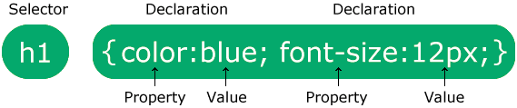

The selector points to the HTML element you want to style. The declaration block contains one or more declarations separated by semicolons. Each declaration includes a CSS property name and a value, separated by a colon. Multiple CSS declarations are separated with semicolons, and declaration blocks are surrounded by curly braces.

**Example**

In this example all <p> elements will be center-aligned, with a red text color:

p {

color: red;

text-align: center;

}

Example Explained

p is a selector in CSS (it points to the HTML element you want to style: <p>).

color is a property, and red is the property value

text-align is a property, and center is the property value

**CSS Selectors**

CSS selectors are used to "find" (or select) the HTML elements you want to style. We can divide CSS selectors into five categories:

* Simple selectors (select elements based on name, id, class)
* Combinator selectors (select elements based on a specific relationship between them)
* Pseudo-class selectors (select elements based on a certain state)
* Pseudo-elements selectors (select and style a part of an element)
* Attribute selectors (select elements based on an attribute or attribute value)
* This page will explain the most basic CSS selectors.

**The CSS element Selector**

The element selector selects HTML elements based on the element name.

**Example**

Here, all <p> elements on the page will be center-aligned, with a red text color:

p {

text-align: center;

color: red;

}

**The CSS id Selector**

The id selector uses the id attribute of an HTML element to select a specific element. The id of an element is unique within a page, so the id selector is used to select one unique element. To select an element with a specific id, write a hash (#) character, followed by the id of the element.

**Example**

The CSS rule below will be applied to the HTML element with id="para1":

#para1 {

text-align: center;

color: red;

}

**Three Ways to Insert CSS**

There are three ways of inserting a style sheet:

* External CSS
* Internal CSS
* Inline CSS

**External CSS**

With an external style sheet, you can change the look of an entire website by changing just one file! Each HTML page must include a reference to the external style sheet file inside the <link> element, inside the head section.

**Example**

External styles are defined within the <link> element, inside the <head> section of an HTML page:

<!DOCTYPE html>

<html>

<head>

<link rel="stylesheet" href="mystyle.css">

</head>

<body>

<h1>This is a heading</h1>

<p>This is a paragraph.</p>

</body>

</html>

An external style sheet can be written in any text editor, and must be saved with a .css extension. The external .css file should not contain any HTML tags, Here is how the "mystyle.css" file looks:

"mystyle.css"

body {

background-color: lightblue;

}

h1 {

color: navy;

margin-left: 20px;

}

**Internal CSS**

An internal style sheet may be used if one single HTML page has a unique style. The internal style is defined inside the <style> element, inside the head section.

**Example**

Internal styles are defined within the <style> element, inside the <head> section of an HTML page:

<!DOCTYPE html>

<html>

<head>

<style>

body {

background-color: linen;

}

h1 {

color: maroon;

margin-left: 40px;

}

</style>

</head>

<body>

<h1>This is a heading</h1>

<p>This is a paragraph.</p>

</body>

</html>

**Inline CSS**

An inline style may be used to apply a unique style for a single element. To use inline styles, add the style attribute to the relevant element. The style attribute can contain any CSS property.

**Example**

Inline styles are defined within the "style" attribute of the relevant element:

<!DOCTYPE html>

<html>

<body>

<h1 style="color:blue;text-align:center;">This is a heading</h1>

<p style="color:red;">This is a paragraph.</p>

</body>

</html>

**2.5 About PHP**

PHP is a general-purpose scripting language geared towards web development. It was originally created by Danish-Canadian programmer Rasmus Lerdorf in 1994. The PHP reference implementation is now produced by The PHP Group. PHP originally stood for Personal Home Page, but it now stands for the recursive initialism PHP: Hypertext Preprocessor.

PHP code is usually processed on a web server by a PHP interpreter implemented as a module, a daemon or as a Common Gateway Interface (CGI) executable. On a web server, the result of the interpreted and executed PHP code – which may be any type of data, such as generated HTML or binary image data – would form the whole or part of an HTTP response. Various web template systems, web content management systems, and web frameworks exist which can be employed to orchestrate or facilitate the generation of that response. Additionally, PHP can be used for many programming tasks outside of the web context, such as standalone graphical applications and robotic drone control. PHP code can also be directly executed from the command line.

The standard PHP interpreter, powered by the Zend Engine, is free software released under the PHP License. PHP has been widely ported and can be deployed on most web servers on almost every operating system and platform, free of charge.

The PHP language evolved without a written formal specification or standard until 2014, with the original implementation acting as the de facto standard which other implementations aimed to follow. Since 2014, work has gone on to create a formal PHP specification.

**What is PHP?**

PHP is an acronym for "PHP: Hypertext Preprocessor". PHP is a widely-used, open source scripting language. PHP scripts are executed on the server. PHP is free to download and use. PHP is an amazing and popular language!

It is powerful enough to be at the core of the biggest blogging system on the web (WordPress)!. It is deep enough to run the largest social network (Facebook)!. It is also easy enough to be a beginner's first server side language.

**What is a PHP File?**

PHP files can contain text, HTML, CSS, JavaScript, and PHP code. PHP code is executed on the server, and the result is returned to the browser as plain HTML. PHP files have extension ".php".

**What Can PHP Do?**

* PHP can generate dynamic page content
* PHP can create, open, read, write, delete, and close files on the server
* PHP can collect form data
* PHP can send and receive cookies
* PHP can add, delete, modify data in your database
* PHP can be used to control user-access
* PHP can encrypt data
* With PHP you are not limited to output HTML. You can output images, PDF files, and even Flash movies. You can also output any text, such as XHTML and XML.

**Why PHP?**

* PHP runs on various platforms (Windows, Linux, Unix, Mac OS X, etc.)
* PHP is compatible with almost all servers used today (Apache, IIS, etc.)
* PHP supports a wide range of databases
* PHP is free. Download it from the official PHP resource: www.php.net
* PHP is easy to learn and runs efficiently on the server side

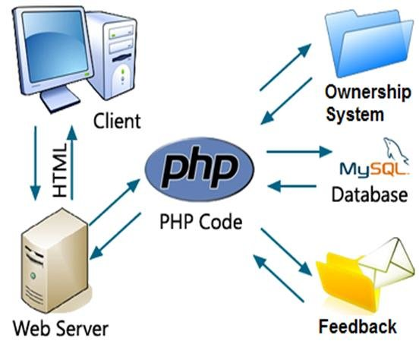

PHP is a server-side scripting language designed to be used for web purposes. Originally PHP was short for “Personal Home Page” but over time it evolved to include that in its recursive current expansion “PHP: Hypertext Preprocessor”. Server-side scripting languages interpret scripts on the server side rather than client-side (like JavaScript).

Doing so provides a customized interface for each user and adds functionality beyond what HTML can offer. Scripting languages are programming languages that are interpreted rather than needing to be compiled before execution.

**What problem does it solve?**

PHP allows for interactive features not possible with HTML. In its earliest days it was used for hit counters and guest books. Now developers use PHP to create web forms, forums, complex shopping carts, and other features that encourage two-way interaction with visitors. Since PHP is a dynamically typed language, it’s also highly flexible. There are no rules on how to build features, so developers have plenty of room for innovation. The tool’s flexibility goes beyond ease of use, too. PHP can handle a wide range of data types.It integrates with all the popular databases including MySQL, Postgres, Oracle, and MS SQL Server.

PHP is well-maintained and supported by a huge community. As such it’s likely to stay more current than other mature tools. One side benefit of its popularity is that finding skilled developers is easy. Programmer productivity stays high with PHP. It operates at a request level with a full state reset for each request, so programmers have a more streamlined development experience. The structure makes debugging easier.

**Weaknesses of PHP**

* PHP’s main strength - flexibility - is also its weakness. It can be a little too forgiving of errors.
* With no strict rules, inexperienced programmers have the freedom to create some very bad solutions to simple problems.
* Bad packages that got popular in the community are still reused when developers are trying something new or rushed for time. Some of these mistakes lead to security risks.
* As a mature tool PHP has some legacy baggage. There are lots of internal consistencies, especially surrounding references and values.
* This is mostly due to updates which add features that clash with earlier features.
* PHP is an interpreted language, which can reduce speed.
* PHP 7 increased performance over previous versions by a significant amount while maintaining most language compatibility.
* The changes didn’t affect the learning curve or existing applications much while improving performance. Still, it executes more slowly than compiled languages.
* Scaling and maintaining PHP is a complicated endeavor.
* Context matters a great deal in dynamically typed languages, so tracking down errors gets harder the larger an application grows.

**Chapter 3**

**System Analysis**

The proposed system is to development an online web application environment to allow user to upload the activity reports in the form of pdf format and later verifying the same for the score gained. Also the project is able to estimate the grade for the institute based on the score gained.

**3.1 Functional Requirements**

This web application is developing two modules

* Admin module
* Labour module
* Contractor module

1. **Admin module**

* Admin can login to the dashboard.
* Admin can approved/disapproved labour and contractor accounts.
* Admin can view subscription details of labour and contractor.
* Admin can logout.

**ii. Labour Module:**

* Labours can login to the system using user name and password.
* Labours can register as a subscription to the portal.
* Labours can view today’s job offers.
* Labours can provide willingness to the job or employee.
* Labours can get notification for work opportunity through mail or telegram.
* Labours can refer other labours.
* Labours can logout from dashboard.

**iii. Contractor module:**

* Contractor can login dashboard.
* Contractor can search (by choosing GPS values) for the nearby labours along with count.
* Contractor can rise the notification to the required numbers of labours by entering the count of labours.
* Contractor can get responses from the labours regarding willingness.
* Contractor should be allow choose the remaining labours whenever the expected responses were not reached.
* Contractor can register to the portal.
* Contractor can create work profiles.
* Contractor can logout.

**3.3 Non-Functional Requirements:**

**Accessible:**

Since the project is Web based, the database and all its corresponding documents are stored in centralized database and storage. Hence it can be accessed from any part of the world.

**Security:**

Since the credentials are provided for all users for login and logout, the system is highly secure.

**Portability:**

Since the software is web based can be browsed in devices namely mobile, laptop, tablets and etc. hence the system is portable.

**Chapter 4**

**Hardware and Software**

**Technology used**

**Product perspective**: This project can be created as a web portal and made available to public. There by it can be brought to the market as product through login credentials.

**4.1 Software Interface:**

**Server:** XAMPP (Apache, MySQL, PHP and Perl on Multiplatform)

**Database:** MySQL server through php my admin

**Development:** HTML, CSS, JavaScript

**4.2 Hardware interface:**

XAMPP runs on Windows 10 hence the minimum hardware requirements of windows 10 considered below

**Processor:** 1 gigahertz (GHz) or faster processor.

**RAM:** 1 gigabyte (GB) for 32-bit or 2 GB for 64-bit.

**Hard disk space:** 16 GB for 32-bit OS or 20 GB for 64-bit OS.

**Graphics card:** DirectX 9 or later with WDDM 1.0 driver.

**Chapter 5**

**System Design**

**5.1 Architecture**

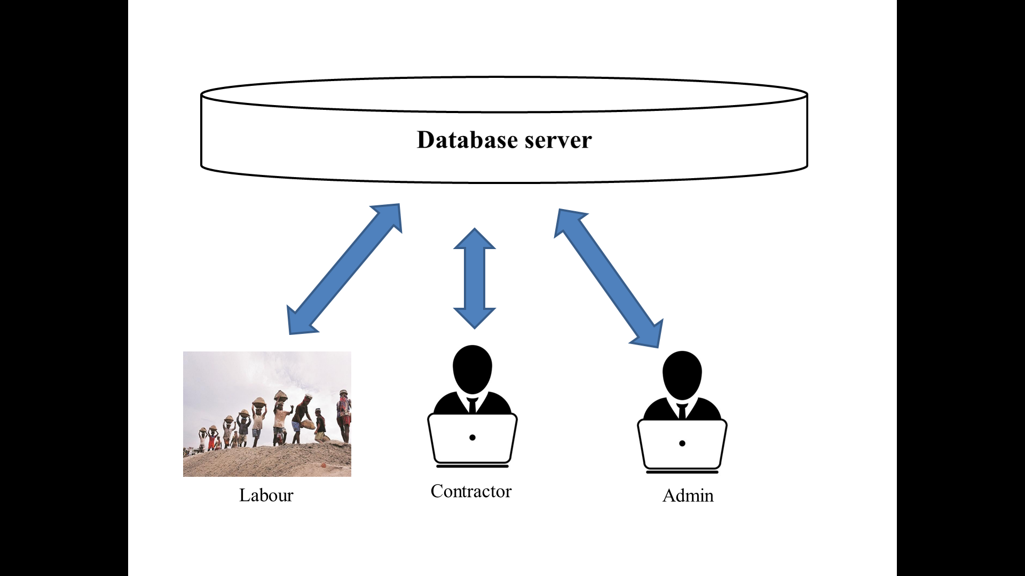

Figure : Architecture of the proposed system

Figure shows the architecture of the project document repository system. This will have major users of the system who will be updating and accessing the centralized document repository.

**5.2 Front end designs: Usecase diagrams**

**Labour Usecase diagram**

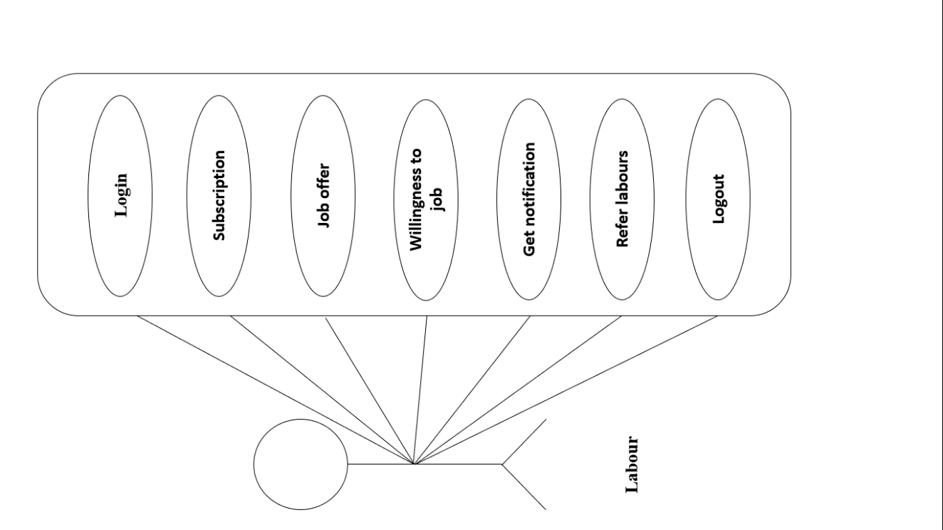

**Contractor usecase diagram**

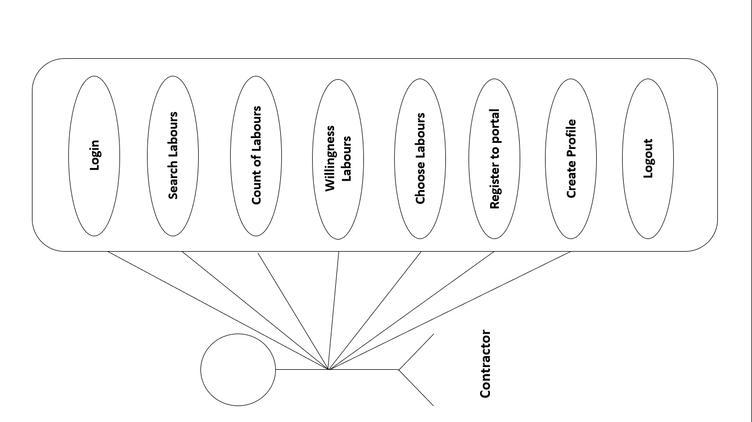

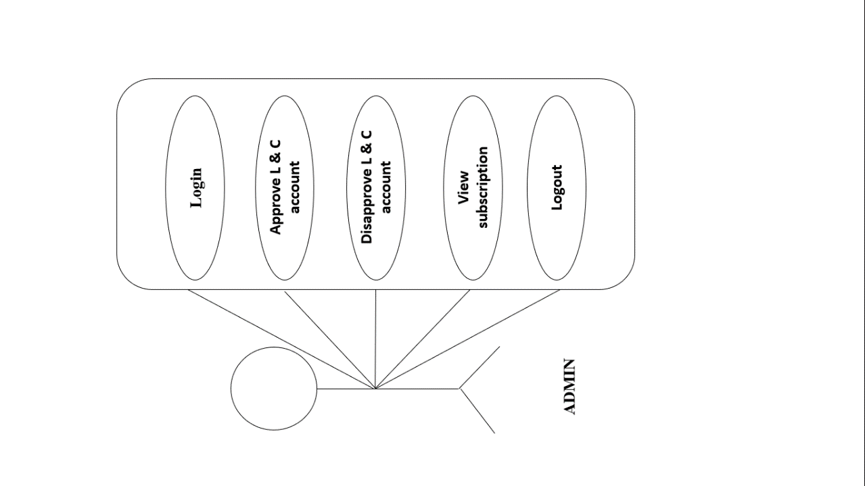**Admin usecase diagram**

**Interaction Diagram**

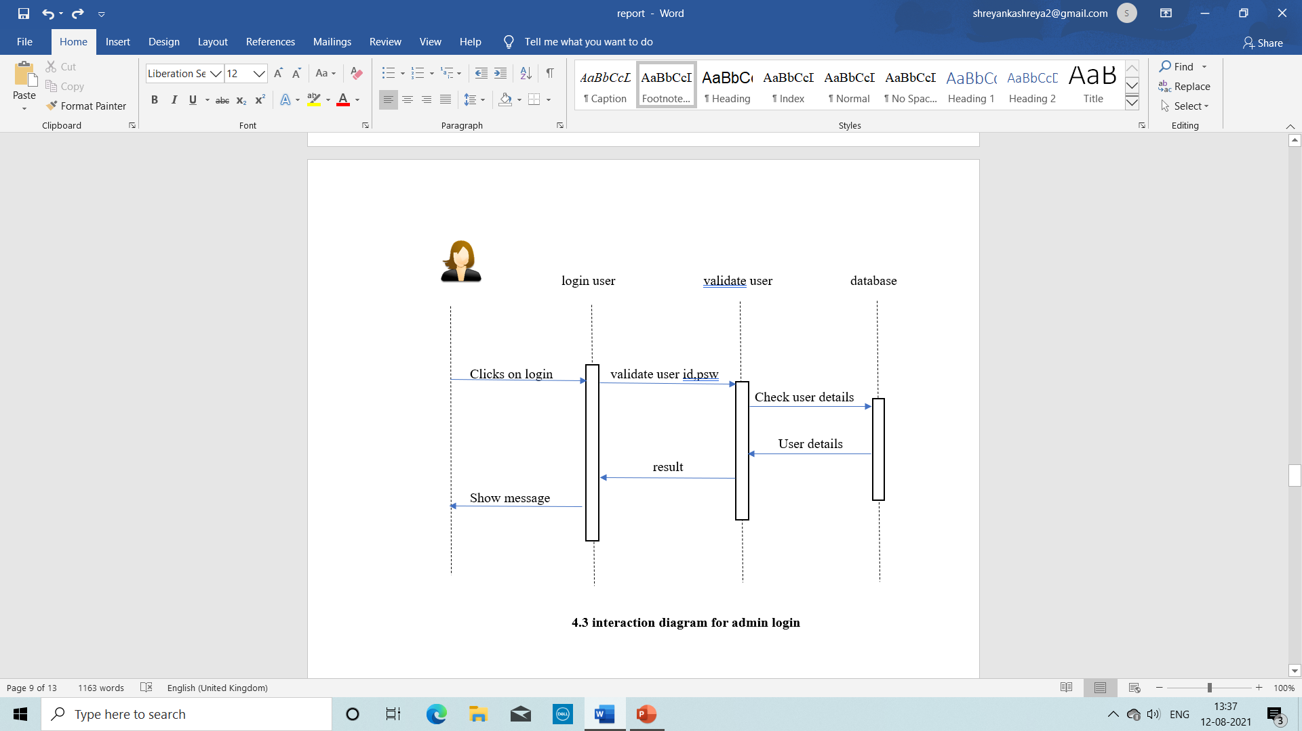**5.4.1 Login**

**5.5 Database Design**

**5.5.1 ER diagram**

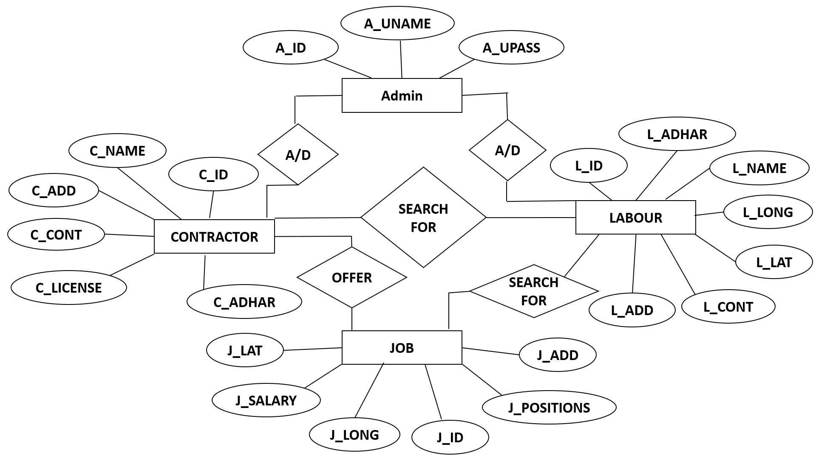

Figure: ER Diagram

The above ER diagram has entities namely file, user and activity. These entities are attached with the required properties.

**Chapter 6**

**System Implementation**

**6.1 Login Script**

<?php

include "db.php";

if (isset($_POST['username'])){

// removes backslashes

$username = $_REQUEST['username'];

$password = $_REQUEST['password'];

$query = "SELECT * FROM `login_tab` WHERE luname='$username' and lupass='$password' and uenable=1";

$result = mysqli_query($con,$query) or die(mysql_error());

$result1 = mysqli_query($con,$query) or die(mysql_error());

$rows = mysqli_num_rows($result);

if($rows==1){

$records = mysqli_fetch_assoc($result1);

$utype = $records['utype'];

if ($utype==1)

header("Location: adminindex.php");

elseif ($utype==2)

header("Location: contractorindex.php?user=$username");

elseif ($utype==3)

header("Location: labourindex.php?user=$username");

}

else

{

echo "<div class='form'>

<h3>Username/password is incorrect.</h3>

<br/>Click here to <a href='index.html'>Login</a></div>";

}

}

?>

**6.2 Enable or Disable Labour**

<?php

include "db.php";

if (isset($_POST['apcontractor']))

{

$appid = $_POST['approvecontractor'];

$query1 = "update login_tab set uenable=1 where lid=$appid";

$result23 = mysqli_query($con,$query1) or die(mysqli_error());

}

if (isset($_POST['dpcontractor']))

{

$appid = $_POST['discontractor'];

$query1 = "update login_tab set uenable=0 where lid=$appid";

$result23 = mysqli_query($con,$query1) or die(mysqli_error());

}

$query114 = "SELECT * FROM login_tab where utype=3 and uenable=0";

$result114 = mysqli_query($con,$query114) or die(mysqli_error());

echo "<form action='adl.php' method='post'><select name='approvecontractor'>";

while ($row114 = mysqli_fetch_assoc($result114))

{

$query115 = "SELECT * FROM labour_tab where luname = '$row114[luname]'";

$result115 = mysqli_query($con,$query115) or die(mysqli_error());

$row115 = mysqli_fetch_assoc($result115);

echo "<option value=$row114[lid]>$row115[lname] - $row115[ladd] - $row115[lcont]</option>";

}

echo "</select><br><input type='submit' value='Approve the contractor' name='apcontractor'></form>";

echo "<Br><BR>";

$query114 = "SELECT * FROM login_tab where utype=3 and uenable=1";

$result114 = mysqli_query($con,$query114) or die(mysqli_error());

echo "<form action='adl.php' method='post'><select name='discontractor'>";

while ($row114 = mysqli_fetch_assoc($result114))

{

$query115 = "SELECT * FROM labour_tab where luname = '$row114[luname]'";

$result115 = mysqli_query($con,$query115) or die(mysqli_error());

$row115 = mysqli_fetch_assoc($result115);

echo "<option value=$row114[lid]>$row115[lname] - $row115[ladd] - $row115[lcont]</option>";

}

echo "</select><br><input type='submit' value='Disapprove the contractor' name='dpcontractor'></form>";

?>

**6.3 Contractor registration**

<?php

include "db.php";

$msg = "";

if (isset($_POST['labregister']))

{

$lname = $_POST['lname'];

$ladd = $_POST['ladd'];

$lcont = $_POST['lcont'];

$llat = $_POST['llat'];

$llong = $_POST['llong'];

$clicense = $_POST['clicense'];

$lusername = $_POST['lusername'];

$luserpass = $_POST['luserpass'];

$query1 = "INSERT INTO contractor_tab (cname,cadd, ccont, clat, clong, clicense, cuname) values ('$lname', '$ladd', '$lcont','$llat', '$llong','$clicense','$lusername')";

$result23 = mysqli_query($con,$query1) or die(mysqli_error());

$query2 = "INSERT INTO login_tab (luname, lupass, utype) values ('$lusername', '$luserpass', 2)";

$result24 = mysqli_query($con,$query2) or die(mysqli_error());

$msg = "Contractor record inserted successfully";

}

?>

**6.4 Labour registration**

<?php

include "db.php";

$msg = "";

if (isset($_POST['labregister']))

{

$lname = $_POST['lname'];

$ladd = $_POST['ladd'];

$lcont = $_POST['lcont'];

$llat = $_POST['llat'];

$llong = $_POST['llong'];

$ladhaar = $_POST['ladhaar'];

$lusername = $_POST['lusername'];

$luserpass = $_POST['luserpass'];

$query1 = "INSERT INTO labour_tab (lname, ladd,lcont,llat, llong, ladhaar, luname) values ('$lname', '$ladd', '$lcont','$llat', '$llong', '$ladhaar', '$lusername')";

$result23 = mysqli_query($con,$query1) or die(mysqli_error());

$query2 = "INSERT INTO login_tab (luname, lupass, utype) values ('$lusername', '$luserpass', 3)";

$result24 = mysqli_query($con,$query2) or die(mysqli_error());

$msg = "Labour record inserted successfully";

}

?>

**6.4 View Job Offers**

<?php

$query21 = "select * from work_profile_tab order by wpid desc";

$result21 = mysqli_query($con, $query21);

?>

<table width="100%" border=1>

<tr>

<Td>

Name and Description

</td>

<Td>

Job Date

</td>

<Td>

Job Location

</td>

<Td>

Say Yes

</td>

</tr>

<?php

while ($row114 = mysqli_fetch_assoc($result21))

{

echo "<tr>

<Td>

<b>$row114[wpname]</b>: $row114[wpdesc]

</td>

<Td>

$row114[wpdate]

</td>

<Td>

$row114[wpaddress]

</td>

<Td>

$row114[wpcont]

</td>

</tr>";

}

?>

**Chapter 7**

**System Testing**

This chapter explains the testing part of the project work. Here some of the use cases have been tested and documented as per the table.

**Software Testing** is a method to check whether the actual software product matches expected requirements and to ensure that software product is Defect free. It involves execution of software/system components using manual or automated tools to evaluate one or more properties of interest. The purpose of software testing is to identify errors, gaps or missing requirements in contrast to actual requirements.

Some prefer saying Software testing definition as a White Box and Black Box Testing. In simple terms, Software Testing means the Verification of Application Under Test (AUT). This Software Testing course introduces testing software to the audience and justifies the importance of software testing.

**Why Software Testing is Important?**

Software Testing is Important because if there are any bugs or errors in the software, it can be identified early and can be solved before delivery of the software product. properly tested software product ensures reliability, security and high performance which further results in time saving, cost effectiveness and customer satisfaction.

**What is the need of Testing?**

Testing is important because software bugs could be expensive or even dangerous. Software bugs can potentially cause monetary and human loss, and history is full of such examples.

In April 2015, Bloomberg terminal in London crashed due to software glitch affected more than 300,000 traders on financial markets. It forced the government to postpone a 3bn pound debt sale. Nissan cars recalled over 1 million cars from the market due to software failure in the airbag sensory detectors. There has been reported two accident due to this software failure.

Starbucks was forced to close about 60 percent of stores in the U.S and Canada due to software failure in its POS system. At one point, the store served coffee for free as they were unable to process the transaction. Some of Amazon’s third-party retailers saw their product price is reduced to 1p due to a software glitch. They were left with heavy losses.

Vulnerability in Windows 10. This bug enables users to escape from security sandboxes through a flaw in the win32k system. In 2015 fighter plane F-35 fell victim to a software bug, making it unable to detect targets correctly.

China Airlines Airbus A300 crashed due to a software bug on April 26, 1994, killing 264 innocents live. In 1985, Canada’s Therac-25 radiation therapy machine malfunctioned due to software bug and delivered lethal radiation doses to patients, leaving 3 people dead and critically injuring 3 others. In April of 1999, a software bug caused the failure of a $1.2 billion military satellite launch, the costliest accident in history.

In May of 1996, a software bug caused the bank accounts of 823 customers of a major U.S. bank to be credited with 920 million US dollars.

**7.1 Unit testing**

A unit test is a way of testing a unit - the smallest piece of code that can be logically isolated in a system. In most programming languages, that is a function, a subroutine, a method or property. Modern versions of unit testing can be found in frameworks like JUnit, or testing tools like TestComplete. Look a little further and you will find SUnit, the mother of all unit testing frameworks created by Kent Beck.

A unit can be almost anything you want it to be -- a line of code, a method, or a class. Generally though, smaller is better. Smaller tests give you a much more granular view of how your code is performing. There is also the practical aspect that when you test very small units, your tests can be run fast; like a thousand tests in a second fast.

Consider this sample code:

def divider (a, b)

return a/b

end

Using Ruby, those small tests might look something like this:

class smallTest < MiniTest::Unit::testCase

def tiny_test

@a=9

@b=3

assert_equal(3, divider(a, b))

end

end

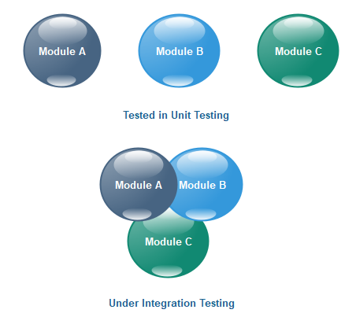

This example is overly simple, but it gives you an idea of what I mean by small. Small tests also have the benefit of making it harder to cross systems from code into a database, or 3rd party system. Strictly speaking, there isn't anything wrong with crossing systems, but there are consequences like gradually slowing your tests.

**7.2 Integration testing**

Integration testing (sometimes called integration and testing, abbreviated I&T) is the phase in software testing in which individual software modules are combined and tested as a group. Integration testing is conducted to evaluate the compliance of a system or component with specified functional requirements

**7.3 Test cases as per the project work**

|  |  |  |  |  |
| --- | --- | --- | --- | --- |
| **Test Case ID** | **Test Case** | **Expected outcome** | **Actual Outcome** | **Remarks** |
| TC #1 | Admin login to the system | Admin should be able to enter username and password and login to the system | Admin is able to enter username and password and login to the system | PASS |
| TC #2 | Allow Contractor and Lobours to register by providing their details | Contractors and Labours should be a provided a registration form to register | Hyperlinks have been provided for both contractors and Labours to register to the system | PASS |
| TC #3 | Contractors to update job offers of the day | Contractors should be able to update the current job offers with date and time along with GPS values of the job location | System has provided an interface to the contractor to update job profiles | PASS |
| TC #4 | Labours should be notified with Job profiles | Labours should be provided a notification about the job profiles | Labours have been provided an interface to view the job notifications | PASS |
| TC #5 | Labours should provide willingness | Labour should be able to provide willingness toward job nitifications | Labours are provided with a job jotifications along with willingness button corresponding to the offer | PASS |

**Chapter 8**

**Result and Snapshots**

**8.1 Login page for all the users**

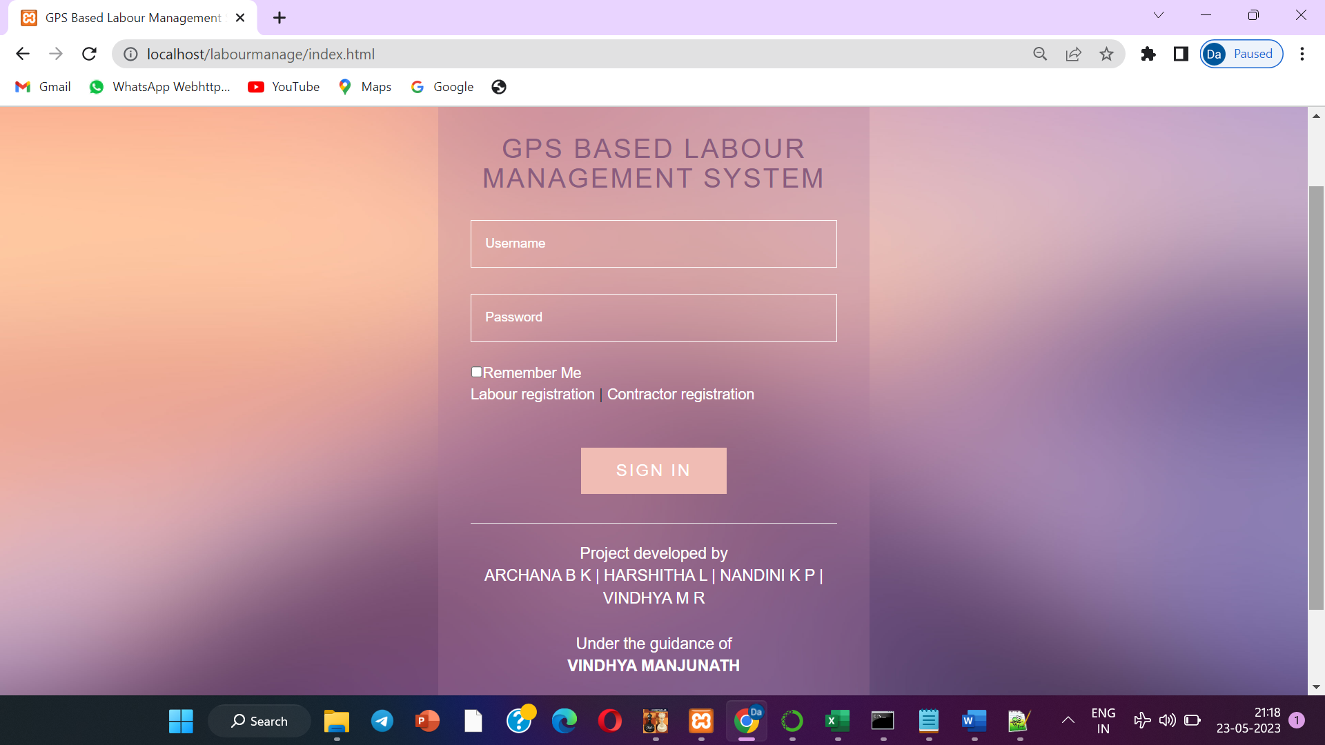

**8.2 Admin dashboard**

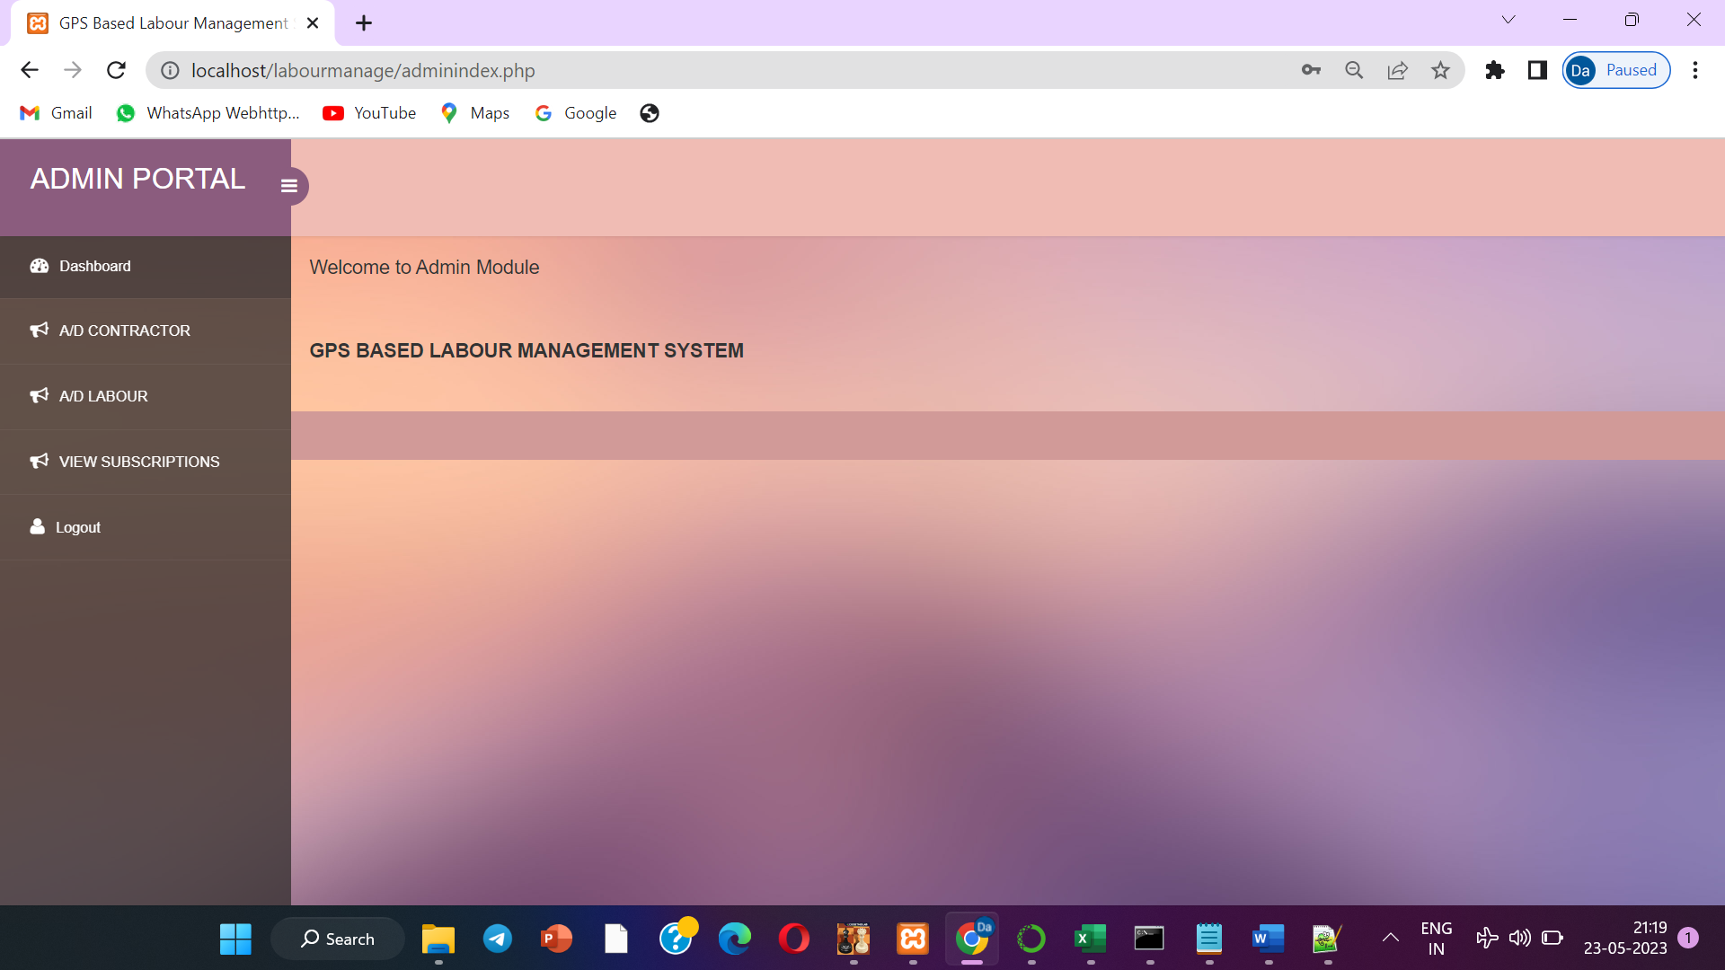

**8.3 Approval and Diapprove process of admin**

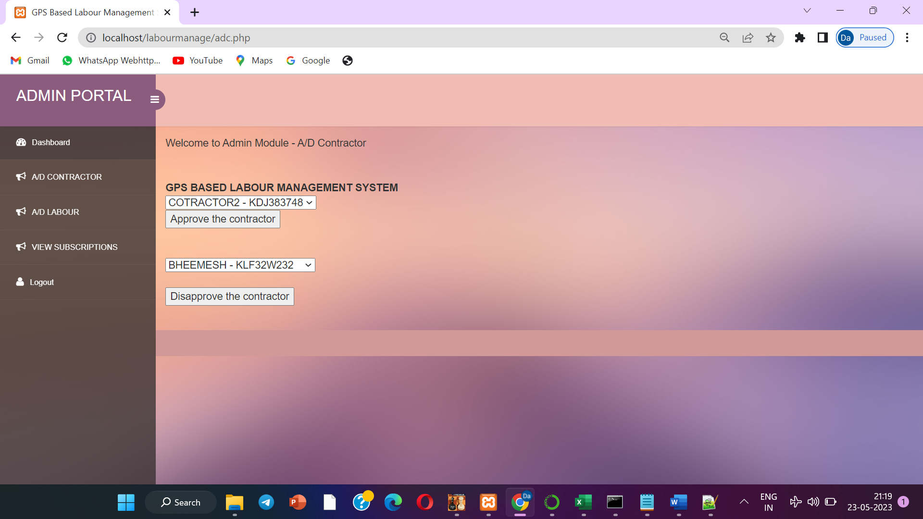

**8.4 Approve or disapprove of Labour accounts**

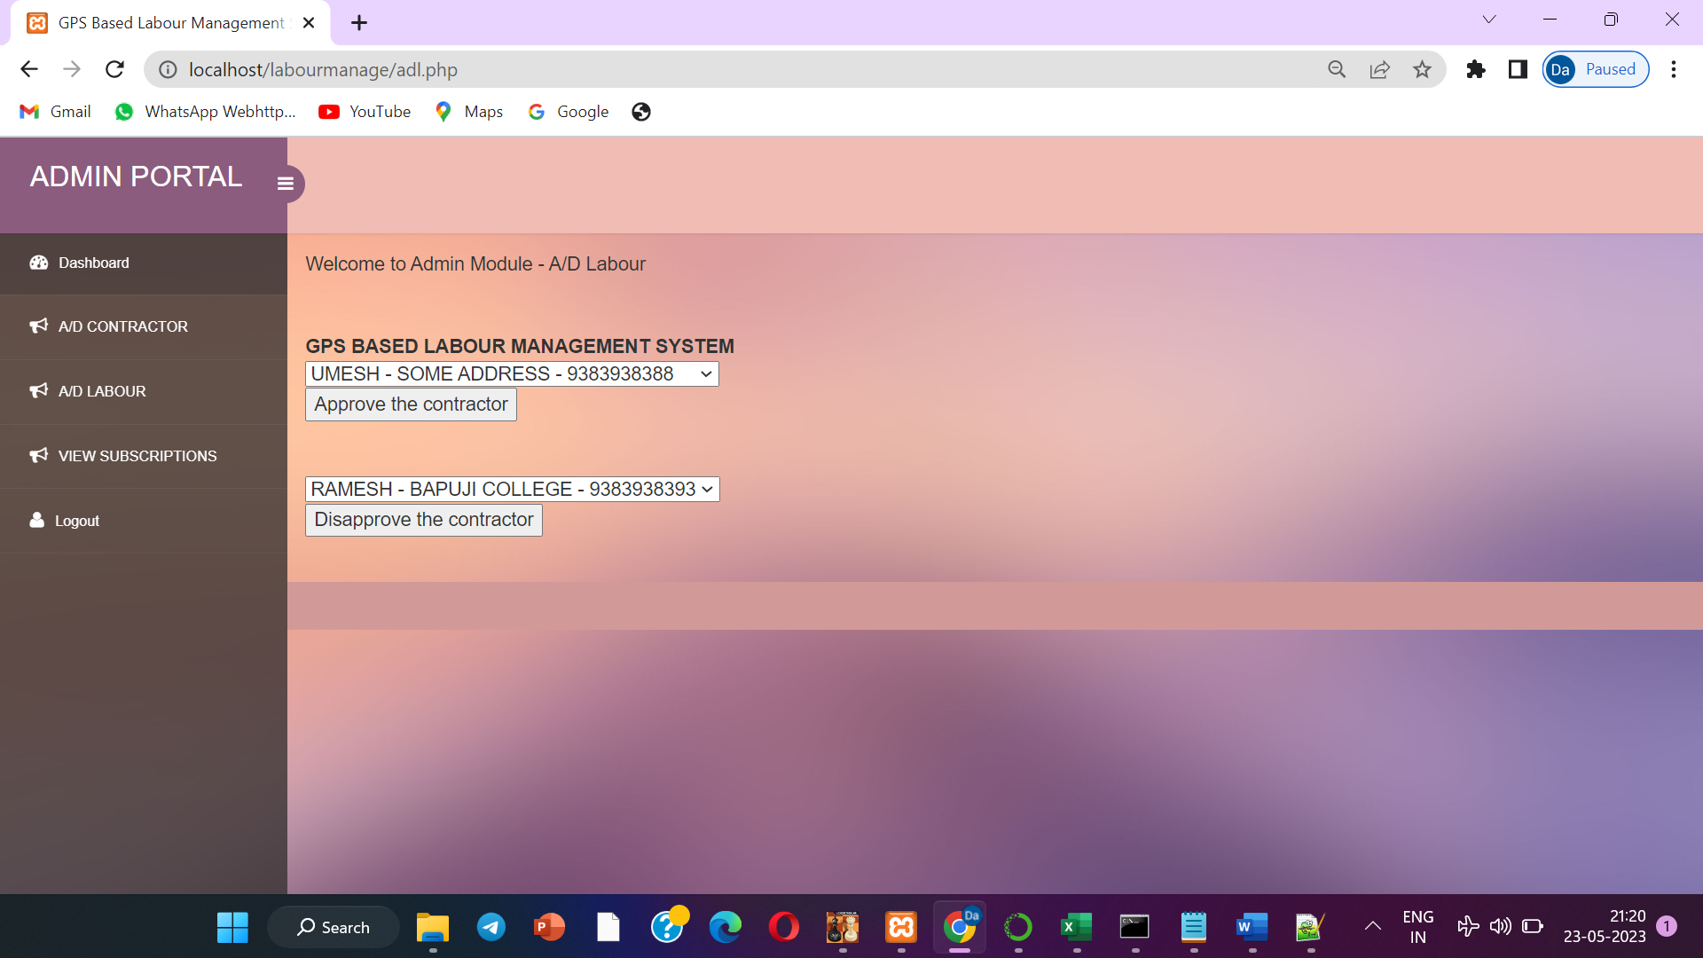

**8.5 Contractor dashboard**

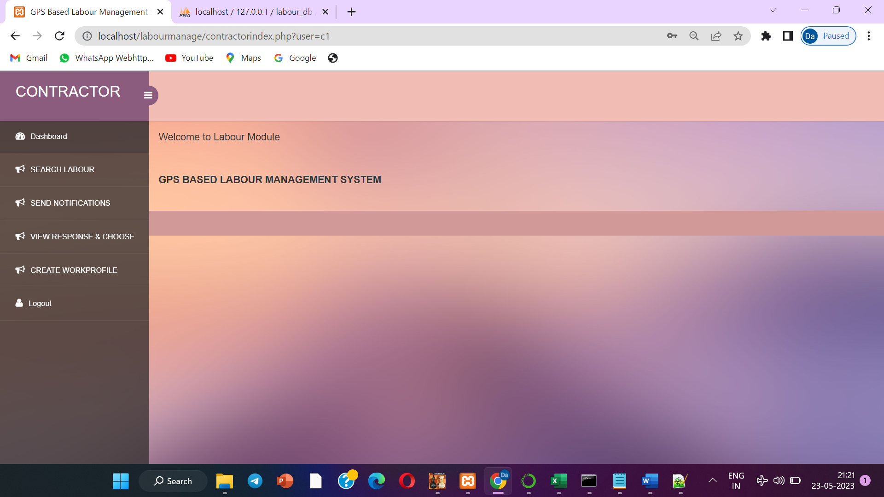

**8.8 Database of the project from phpmyadmin**

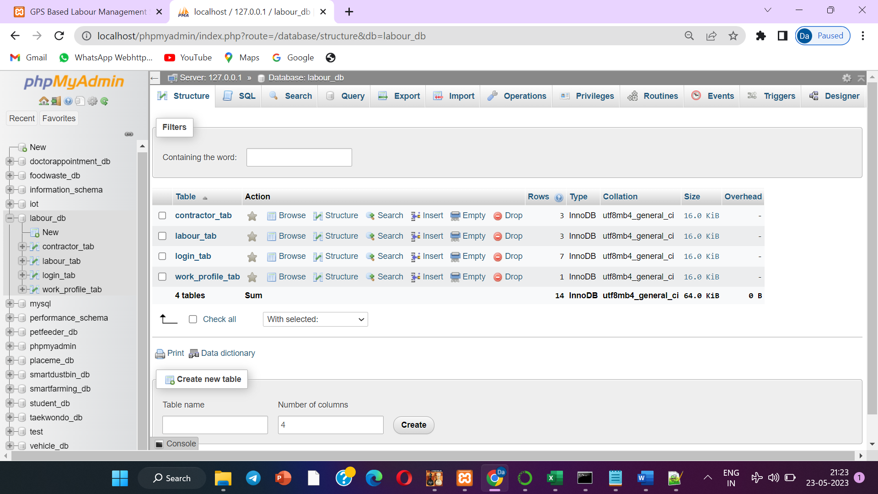

**Chapter 9**

**Conclusion**

The proposed project is trying to provide a common platform for both job seekers and job provide to coordinate with unique criteria. Many of labours, specially daily wages community will be waiting for the job opportunity regularly. If they get any job they follow and earn their food for the day otherwise no food for the day. To support such community the proposed project is trying connect these available labours through their GPS data to the needy job providers / contractors.

**FUTURE SCOPE**

As we developed a web application for GPS Based Labour Management System which allows Contractor to get a near by Labours through GPS and this application can be accessed by using website by sitting in front of System/PC or in cyber center to get the necessary details.

As a future Enhancement we are interested to develop an android app for this application by this android application any user can get details using their mobile instead of going to internet center and also facilitate people to get in there mobile.

**CHAPTER 10**

**Bibliography**

* Welling, Luke, and Laura Thomson. PHP and MySQL Web development. Sams publishing, 2003.
* Lerdorf, Rasmus, et al. Programming PHP. " O'Reilly Media, Inc.", 2002.
* Uddin, Mohammad Salah, et al. "A location based time and attendance system." International journal of computer theory and engineering 6.1 (2014): 36.